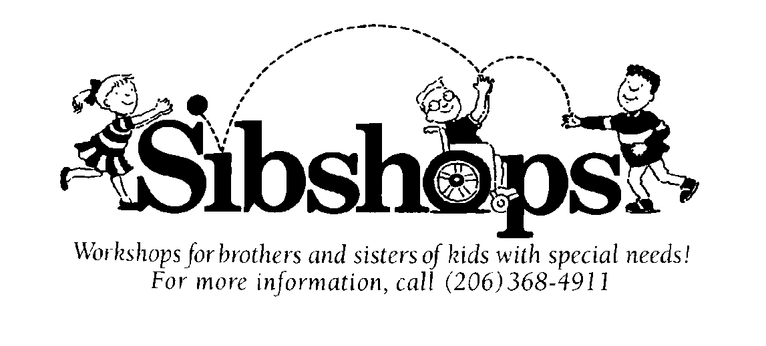
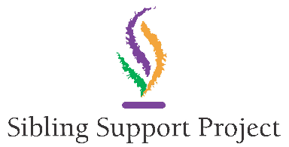
www.siblingsupport.org
Come Join Us for SibShops
An online one-of-a-kind 1 1/2 -hr workshop designed for brothers and sisters of a child with
complex needs - (age 7-13).

What are Sibshops?

- Special Needs, Mental Illness and/or Behavioral Challenges impact the ENTIRE family,
including Siblings!

- Sibshops are a celebration of the many contributions made by these brothers and sisters.

Best of All Sibshops are FREE!
Join us the third Saturday of each month, 10:30am to 12 pm.
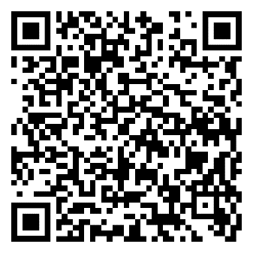
Register at:
Or call Kiki Mulliner at
347-463-5972
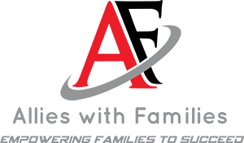
Presented by - Allies With
Families
allieswithfamilies.org

